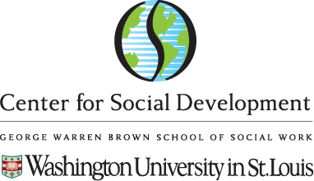
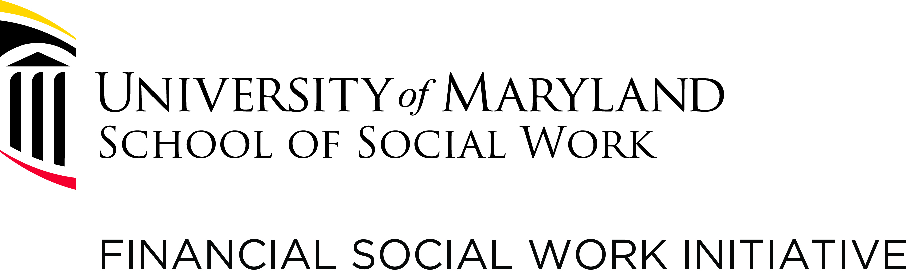

THIRD CONVENING ON FINANCIAL CAPABILITY AND ASSET BUILDING (FCAB):
USING EVIDENCE TO INFLUENCE POLICY AND PRACTICE

January 10 - 11, 2018
COUNCIL FOR ADVANCEMENT AND SUPPORT OF EDUCATION (CASE)
1307 NEW YORK AVENUE, NW, WASHINGTON, DC

Agenda
Wednesday, January 10, 2018

11:00 am Registration
11:30 am – 2:15 pm Luncheon
12:15 – 12:30 pm Welcoming Remarks - Richard Barth, PhD, Jodi Jacobson Frey, PhD, University of Maryland, Baltimore, School of Social Work and Margaret Sherraden, PhD, University of Missouri – St. Louis School of Social Work
12:30 – 1:30 pm Keynote Speaker: Ray Boshara, MAR, MPA, Senior Advisor and Director of the Center for Household Financial Stability, Federal Reserve Bank of St. Louis
Question-and-Answer Portion
1:30 – 4:30 pm Panel Presentations

Building FCAB Evidence through Existing and New Data Sources
1:30 – 2:15 pm Panel 1: A Snapshot of FCAB Research: Cross-Sectional Data Sets
- Survey of Household Economics and Decision-making (SHED): Jeff Larrimore, PhD, Federal Reserve Board
- National Financial Capability Survey: Gary Mottola, PhD, Financial Industry Regulatory Authority (FINRA) and Christine Callahan, PhD, University of Maryland, Baltimore, School of Social Work
- Moderator: Julie Birkenmaier, PhD, Saint Louis University School of Social Work

2:15 – 3:30 pm Panel 2: FCAB Over Time: Longitudinal Data Sets
- Survey of Income and Program Participation (SIPP): Haksoon Ahn, PhD, University of Maryland, Baltimore, School of Social Work
- Panel Study of Income Dynamics (PSID): Jin Huang, PhD, Saint Louis University School of Social Work with Terri Friedline, PhD, University of Kansas School of Social Work and David Rothwell, PhD, School of Social and Behavioral Health Sciences, Oregon State University
- Health and Retirement Study (HRS): Karen Zurlo, PhD, Rutgers University School of Social Work
- Moderator: Jodi Jacobson Frey, PhD, University of Maryland, Baltimore, School of Social Work

3:30 – 4:00 pm Break

4:00 – 5:00 pm Panel 3: FCAB Across the Globe: International and Mixed Data Sets
- Global Financial Inclusion Database (Global FINDEX): David Rothwell, PhD, School of Social and Behavioral Health Sciences, Oregon State University
- Services Mapping Project: Terri Friedline, PhD, University of Kansas School of Social Work and Mat Despard, PhD, Center for Community Capital, University of North Carolina – Chapel Hill
- Moderator: Margaret Sherraden, PhD, University of Missouri – St. Louis School of Social Work

5:00 – 5:30 pm Panel 4: A Sneak Peek into the Future of FCAB Research: Emerging Data Sets
    - Consumer Financial Protection Bureau: Genevieve Melford, MPA (CFPB)
    - Community Advantage Program Database: Mat Despard, PhD, Center for Community Capital, University of North Carolina – Chapel Hill
  - Moderator: Jin Huang, PhD., Saint Louis University School of Social Work

5:30 – 5:40 pm Introduction of Council on Social Work Education (CSWE) Curricular Guide for Economic Well-Being: Jo Ann Regan, PhD, CSWE

5:40 pm Wrap-Up and Dinner Announcement

THIRD CONVENING ON FINANCIAL CAPABILITY AND ASSET BUILDING (FCAB):
USING EVIDENCE TO INFLUENCE POLICY AND PRACTICE
Agenda
Thursday, January 11, 2018
8:30 – 9:10 am Breakfast
9:10 – 9:15 am Welcome from Jin Huang, PhD, Saint Louis University School of Social Work and Introduction of Keynote Speaker
9:15 – 9:45 am Keynote Speaker - Charles Lewis, PhD, Director, Congressional Research Institute for Social Work and Policy (CRISP)
9:45 – 11:00 am Working Groups (see hand-outs for description, discussion, and dialogue)
11:00 – 11:30 am Reporting Back and Q&A
11:30 am – Noon Adjournment and Lunch on Your Own (SSWR sessions start at 1 pm)

THIRD CONVENING ON FINANCIAL CAPABILITY AND ASSET BUILDING (FCAB):
USING EVIDENCE TO INFLUENCE POLICY AND PRACTICE
WORKING GROUP INSTRUCTIONS
Lead-in questions for all groups based on research questions participants may want to pursue, given what they have heard about data sets and policy needs from the speakers:
- What are the gaps in existing databases?
- How can we further explore the databases?
- What is the priority for FCAB Grand Challenges?
- How can we tie back to data and/or link data to policy pursuits?
- How can we tie back to the survey that was sent previously to researchers? (Will provide this documents with results for reference)
Possible goals/outcomes for the working groups:
- To form partnerships
- To create action steps towards policy and/or practice change or influence
- To write more, e.g., op-ed pieces, media communications
- To form research teams to work on new projects
- To search for funding
- To coordinate efforts across university or setting
Bottom line: what do you want to have happen in your group?

