BHWISE SUDIF Student Essay

Name: Click or tap here to enter text.
UMB Email: Click or tap here to enter text. Student @ ID Click or tap here to enter text.
Additional Email: Click or tap here to enter text. Phone: Click or tap here to enter text.
Campus: ☐Baltimore ☐ USG (check one)

Briefly describe how your professional goals align with BHWISE SUDIF to advance and increase the social work behavioral health workforce in substance use treatment, and why you should be considered for this opportunity. (500 word minimum)

Click or tap here to enter text.

Signature: Click or tap here to enter text. Date: Click or tap here to enter text.
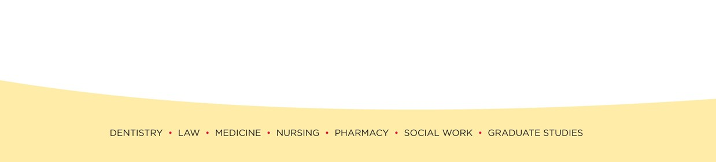
Submit signed essay to BHWISE@ssw.umaryland.edu
ALL application requirements are due by March 15

To be eligible for BHWISE SUDIF you cannot enroll in any of the following programs:
International Field placement Title IV-E HEALS Scholars BHWISE Lifespan BHWISE IOWA Financial Social Work Initiative (FSWI)

