Faculty Organization Meeting
October 10, 2018
Started at: 12:15pm

- Review and approve September minutes (2 minutes)

Summary/Action | Responsible Party (if appropriate)
John Belcher moved to approve the minutes, seconded by Geoff Grief | Jodi Frey

- Deans’ and Directors’ Report – Part I (10 minutes)

Summary/Action | Responsible Party (if appropriate)
Rick Barth – offered the possibility of moving the FO meeting up to one of the new rooms on the third floor. Will discuss in FEC meeting.  We should hear from CSWE about their visit within the next week or so.  The PhD program review is complete and we received positive feedback, formal feedback will be provided at a later time.  Rick discussed forming a subcommittee to develop recommendations around promotion lines for non-tenured titles – the sub-committee will be comprised of Rick Barth, Megan Meyer, Joan Pitman, a member of the APT committee, and others. The idea is to examine the adjunct and Clinical Instructor lines.  We are continuing to try and improve space. There will be offices added to the mail room area so that there are two offices and some swing space. SWCOS space is looking good. | Rick Barth

- Presentation/Discussion: Chief Cary, Campus Police (30 minutes)

Summary/Action | Responsible Party (if appropriate)
Presentation by Chief Alice Cary and Deputy Chief Tom Leone  They were forwarded some questions that were received from faculty and staff. Chief Cary was asked to present her vision discuss some of the questions sent earlier and take questions.  Chief Cary – I am campus policing oriented – she wants her officers to be engaged in the campus community – she wants to provide campus programming. Part of that is that we need to have our officers listening. Questions being asked are: how do we communicate with stakeholders, individuals, departments, students? How does communication happen – what mechanisms are the most useful? How do we show the people behind the badge, officers are people too?  Starting a liaison program – homelessness, neighboring communities.  There is a specific team COAST – campus outreach and support team which is being led by Lieutenant Johnson.  Q: Do you know how the officer to student ratio is on campus?  A: We do not know the answer to that?  Q: How big is the staff?  A: There are about 160 policing and other staff – they are allotted 3 additional officer per fiscal year over the coming years as the campus grows.  Q: How are you interfacing with the Baltimore City department?  A: They are going through transitions – she has met with the Chief – meets weekly with the City Intel meetings – attends meetings downtown. Also meets with the VA chief of police.  Q: Evening coverage on campus and patrols between Paca street and the light rail.  A: The Sgts have been tasked with developing policing schedules which is a work in progress. The specifics such as the timing need to be carefully considered, but it is a work in progress.  Q: Can you talk about the homeless liaison role/program?  A: We are offering space in the bio-park station – she is considering a HOT (homeless outreach team) with both local and national outreach. She sees this being a 2 to 3 person team.  Q: What are your broad outlines of the authority – and area served?  A: It is rather hard to describe without a map – campus to Eutaw and across to the bio-park. Some of this is concurrent jurisdiction with the City for offices that are outside of the central campus. As the University expands so does the footprint. They will send a map.  Q: You do these wonderful tours for students – could you do a virtual tour that can be posted?  A: That is a great idea and she will consider that moving forward. They would like to do more videos.  Q: Who in your office would come to help evaluate the safety of space?  A: Probably Deputy Chief Leone– he can do crime prevention through environmental design issues and examination of the panic buttons. Chief Cary wants to hire a security professional.  Q: The patrols in Ridgley’s have been less frequent?  A: the University was paying Baltimore City overtime for additional patrols – this is no longer occurring – campus police continue to patrol the area and this should have been communicated.  Q: Around the Naloxone strategy – what is your thinking around how we approach the emergency administration of Naloxone?  A: Emergency Manager Brad(sp?) would be a good avenue – at the security desk in each school makes sense, currently the officers have them in their vehicles.  Q: For those of us who are trained are you using inter nasal or oral?  A: Oral  Q: You mentioned implicit bias – can you expand on that?  A: We are hoping to do training annually as an in-service – the idea is to train all staff on issues. February is implicit bias awareness month and is a good time to kick this off.  Q: Working with ICE – what happens if someone from ICE comes on campus looking for students.  A: Security is eyes and ears. There are currently no processes around integration with ICE. If there was a warrant presented by ICE the supervisor would be the person to interact with that structure.  Q: Do you have any advice to us if we find there are security issues for students?  A: The campus engagement team will be the point of contact – this will be advertised.  Q: Can you talk about the difference between 911 and 9.911 and also the blue light phone.  A: Starting with the blue light phone – there will be a number on the phone that provides the exact location of the phone – they will all be identified that way although they are not.  9.911 does not provide location information to Baltimore City  711 and 6.333 number is routed to campus and location is provided to campus.  All 911 calls will be routed to the City – campus systems are being upgraded so that this is possible. This is a work in progress.  Q: The only other question is the back door to the SSW building.  A: It should be locked – it is a card reader access currently. Rick said that he wanted the door to be open during the day and locked after 6pm. Deputy Chief Leone will look for other options and monitor. | Chief Cary and Dep. Chief Leone

- Deans’ and Directors’ Reports – Part II (20-30 minutes)

Summary/Action | Responsible Party (if appropriate)
Dave Flinchbaugh discussed the MATCH and that there was an extra $5000 donated because of the match.  Megan Meyer discussed the faculty open space which has been successful. CSWE has a one day institute and Rick has agreed to help defray the costs. If anyone is interested please reach out to Megan. Kristen Hood and Janice Hicks have recently received promotions.  Paul Sacco – next weeks presentation is cancelled  Bethany Lee – search – we have over 140 applicants so far. Next week on Tuesday and Wednesday there will be presentations by applicants. Looking for some people to go to breakfast with the candidates. Shout out to Janice Hicks for all her help. Brandon Greene and Tom Mitchell have been great in facilitating the search.  Charlotte Bright – we have a lot of applicants visiting in the next few weeks – we are looking to connect people to faculty.  Karen Hopkins –on campus interview on November 13 related to the endowed chair search | Deans and Directors

- Faculty Senate update: Ericka Lewis (5 minutes)

Summary/Action | Responsible Party (if appropriate)
Faculty Senate Constitution (see handout below).  Currently the graduate school is suggesting adding representatives including: faculty librarians (1); adjunct faculty (1); part-time faculty (1).  Q: How is the size of school determined?  A: Full time faculty – we might need to reexamine the size of our faculty as we might be due more representation as our faculty has grown.  Q: These have been ex-officio members without voting privileges.  A: correct – we are voting to give them a vote.  Moving it forward to take a vote. Passed unanimously!  Senate constitution currently requires any amendment to the constitution requires approval from all schools.  The proposed adjustment means that any proposal that is approved by FO both of our senate votes would be in conjunction – so 51% approval means two positive senate votes.  -Comment: I do not think that this is a good idea – the simple majority concept is not representative of the possibilities. One suggestion is that 3 schools could be totally opposed and 3 schools could be 51/49 for and it passes meaning that the majority of campus is not for a proposal.  *There is a suggestion that the second vote be tabled for further clarification related to the constitution amendment process. This will be tabled until the next faculty meeting. | Ericka Lewis  Mike Woolley/Ericka Lewis

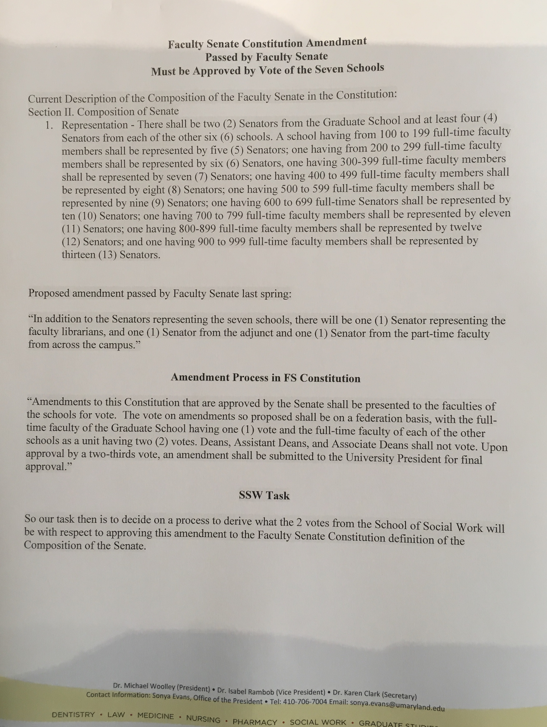
- Diversity and Inclusion update: (5 minutes)

Summary/Action | Responsible Party (if appropriate)
Updates from the DAO  DAO Goals – 2018/2019  -promote diversity and anti-oppression training fro faculty, staff and students  -create more inclusive spaces at the UMSSW  -support implementation of course and content related to oppression and anti-oppression practices  -Develop and facilitate a process to create a plan to make the UMSSW more diverse, inclusive, equitable and just.  They had a discussion around using our space (walls, elevators, doorways) to be more inclusive.  There is a recognition that where we are now is not where we want to be. This is a process where we are striving for growth and betterment – it is not a destination but a direction we have chosen to pursue.  DAO Meeting is Monday, October 15 at 12:15 in room 3e34  Q: In working with Jeff and thinking about the planning process, when might a map of the process be available?  A: Hopefully this will be available in November or December – DAO needs to also review what is presented. | Adam Schneider and Fernando Wagner

- General Announcements (5 minutes)

Summary/Action | Responsible Party (if appropriate)
Announcement from Caroline Burry: In collaboration with LUCHA there will be a brown bag structure that is being put forward – there should be a survey coming soon.

There is a somewhat new program called Prof2Prof – this was presented at FEC – this is an interesting online platform (see handout below). Jodi Frey encouraged faculty to explore the site to see how it could be used and the potential for organizing topics. Webinar link to learn more: https://youtu.be/nDx69vPdyME

Gisele Ferretto – the proposed licensing Regs will be published 10/12 – she will develop a summary and solicit feedback – we have 30 days to provide comments.
NASW Maryland sponsored event related to regulations to be held on October 23 from 9 to 12. There will be a discussion at the Children’s Guild. The plan is to have a panel in each workforce subject areas and then to break into small groups. There is also an NASW student conference and a call for papers with awards.

Geoff Greif – Ken hardy will be presenting on Race and Social Work Practice – November 12, 2018 – in the auditorium and streaming in the classrooms – should be a great discussion on race and social work practice

Nadine Finigan-Carr – the first RYC seminar day is tomorrow here in the auditorium. Fluid over the course of the afternoon.

Thursz social justice lecture is coming up

David Flinchbaugh – tomorrow night at USG will be a panel presentation on opioids – presenters will discuss innovations in opioid prevention and service – Nalini Negi will be presenting

Monday, Nov. 5 – the Student Financial Well-Being Fair from 12-2 in the SSW Auditorium/Atrium – speakers on budgeting, debt, credit financial planning and resources in addition to pizza and a raffle
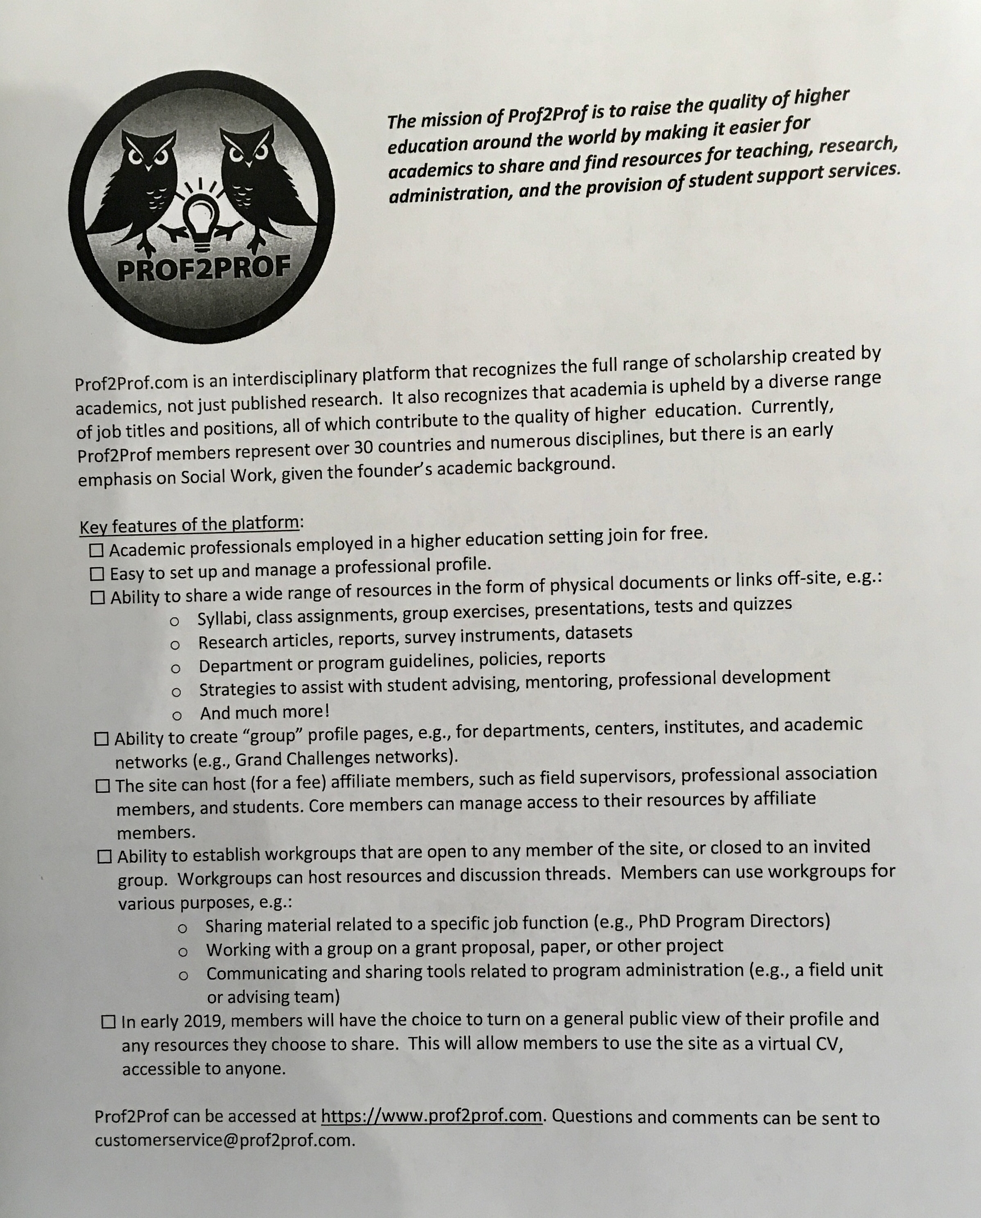

- “Shout-Outs”(5 minutes)

Summary/Action | Responsible Party (if appropriate)
Give a shoutout to SWCOS for its video segment on Good morning America – Social Work in the Libraries program

Shout out to all the many people who helped with the student orientations trainings

Charlotte Bright right for a successful PhD review

Geoff Greif who will be celebrated on the campus

TedX Baltimore– Jules Gilliam and Nadine Finigan-Carr will be presenting

Next meeting Date: 11/14/18
Submitted by: Terry Shaw
Date: 10/10/18

FEC and FO MEETING DATES (2018-19)

FEC Meetings | FO Meetings
September 5th | September 12th
October 3rd | October 10th
November 7th | November 14th
December 5th | December 12th
February 6th | February 13th
March 6th | March 13th
April 3rd | April 10th
May 1st | May 8th
No meeting | June 5th (10am – 2pm)

