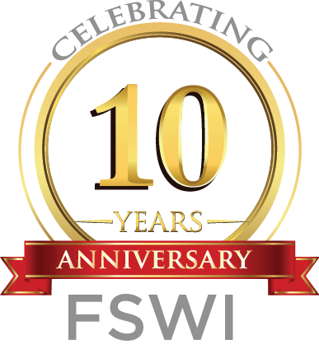

# **SAVE THE DATE!**

# ***STUDENT FINANCIAL WELL-BEING FAIR***

# **MONDAY, NOVEMBER 5, 2018**

# **NOON-2:00 P.M.**

# **UMSSW AUDITORIUM AND ATRIUM**

Join us for UMSSW’S first Student Financial Well-Being Fair! Speakers and representatives, including from UMB’s Financial Aid Office, CASH (Creating Assets, Savings, and Hope) Campaign of Maryland, Guidewell Financial Solutions, and more, will present, talk with students, and share resources about a variety of topics affecting your financial well-being, including:

* Managing debt, including credit cards and student loan debt
* Coming up with spending plans that work
* Getting help with taxes
* Financial goal-setting
* Planning for the future after graduation

Light refreshments will be provided as well.

**MORE INFORMATION TO FOLLOW! CHECK** [**WWW.SSW.UMARYLAND.EDU/FSW**](http://WWW.SSW.UMARYLAND.EDU/FSW) **FOR UPDATES!**