NOTE: Do not post the images from this word document. Please use the full resolution JPGs. Thumbnails are only to match visuals with the copy. Be sure to replace the hashtags and bit.ly links with what is timely and consistent with the campaign – the ones sampled in this copy are not intended for final use. We recommend spreading these posts out over several weeks in order to build overall brand identity and recognition.

GENERAL
FACEBOOK: You won't even have to turn your head and cough. Men, take a mental health physical with this fast, free survey at healthymenmichigan.org.
TWITTER: You won't even have to turn your head and cough. Men, take this fast, free mental health physical. http://bit.ly/2wb4igK #mensmentalhealth

DEPRESSION
FACEBOOK: Depression can sneak up on you faster than a nap after a plate of ribs. Guys, find out where you stand and how you can stay mentally strong. Learn more at healthymenmichigan.org.
TWITTER: Depression can sneak up on you like a nap after a plate of ribs. Get tools to stay mentally strong. http://bit.ly/2wb4igK #mensmentalhealth

stress
FACEBOOK: Stressing during the 4th quarter of a tight game is normal. Letting that stress turn to rage when your team loses, less so. Men, if your emotions are getting the best of you, we've got the tools to help. Learn more at healthymenmichigan.org.
TWITTER: If 4th quarter stress is turning into post-game rage, it's time to work on your late-game strategy. http://bit.ly/2wb4igK #mensmentalhealth
sleep
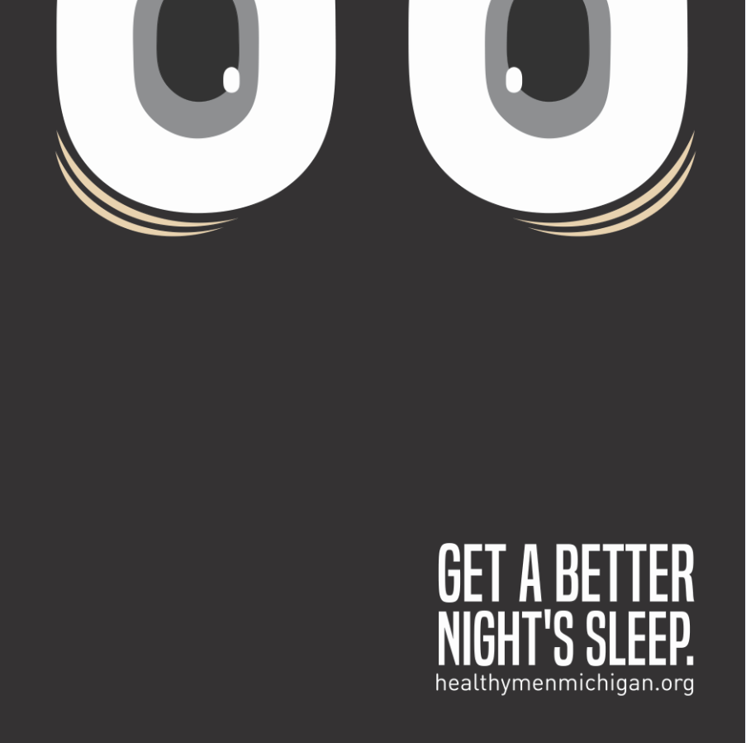
FACEBOOK COPY: Difficulty sleeping could mean you need to lay off the afternoon coffee. But it could also mean you've put your mental health on the backburner. Men, give your mental health a workout. Start with this fast, free survey at healthymenmichigan.org.
TWITTER COPY: Maybe it's the PM coffee, but trouble sleeping could mean it's time for a mental health check-up. http://bit.ly/2wb4igK #mensmentalhealth
anxiety
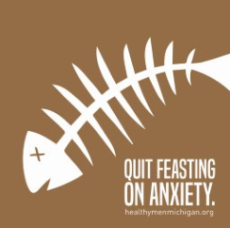
FACEBOOK COPY: Guys, if your thoughts tend to feast on anxiety the way a grizzly feasts on salmon, we can help put that worrisome appetite into hibernation. Learn more at healthymenmichigan.org.
TWITTER COPY: If you feast on anxiety like a grizzly feasts on salmon, put that anxious appetite into hibernation. http://bit.ly/2wb4igK #mensmentalhealth

grief
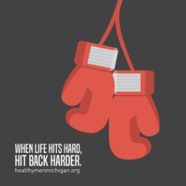
FACEBOOK COPY: When life hits hard, hit back harder. A great comeback is at the heart of every great story. Start your comeback. Visit healthymenmichigan.org.
TWITTER COPY: When life hits hard, hit back harder. It's time to start your comeback story. http://bit.ly/2wb4igK #mensmentalhealth

SUICIDE
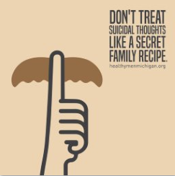
FACEBOOK COPY: Unlike your fantasy football draft strategy, there are some secrets men shouldn't keep. If you're having suicidal thoughts, don't keep them to yourself. Find a friend who'll listen. And find tools to help at healthymenmichigan.org.
TWITTER COPY: Don't treat suicidal thoughts like a secret family recipe. Find a friend who'll listen, and share. http://bit.ly/2wb4igK #mensmentalhealth

