10 Fun Things to do in Baltimore!
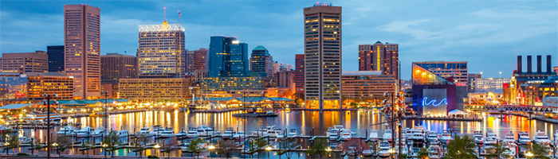

- Check out the art museums!
We are lucky to have so many wonderful collections right here in Baltimore, many of them you can see for free! Go explore the Walters Art Museum, Baltimore Museum of Art, and American Visionary Art Museum.
https://www.thewalters.org/
https://artbma.org/
http://www.avam.org/

- Go to your local park!
There is still plenty of green space in the city! Patterson Park, Druid Hill Park, Federal Hill, and Canton Waterfront Park are just a few of Baltimore’s best parks.
http://bcrp.baltimorecity.gov/parks

- Go see an O’s game!
The Orioles, as well as the school, often offer discounted tickets for students. Play ball!
http://baltimore.orioles.mlb.com

- Wander the neighborhood!
Whether it’s First Fridays in hip Hampden or swing dancing at Mobtown Ballroom in Pigtown, get to know your surroundings and have fun! Also check out Fell’s Point, Little Italy, and Fed Hill!
http://hampdenmerchants.com/
http://www.pigtownmainstreet.org/
http://www.fellspointmainstreet.org/
http://www.littleitalymd.org/
http://www.fedhill.org/

- Eat local at our farmer’s markets!
Try yummy, fresh food at the Baltimore Farmers Market under Jones Falls Expressway on Sundays and University Market across from the SSW from May-November.
http://www.baltimarket.org/farmers-markets/

- Explore the festivals!
Find your inner artist at Artscape or see the history of “Bawlmer” at Honfest! Also coming up, the Baltimore Book Fest from September 23rd-25th!
http://www.artscape.org/
http://honfest.net/
http://www.baltimorebookfestival.com/

- Be a bookwork at Enoch Pratt Free Library!
Whether it’s for the books, free events, or to admire the architecture, you have to go!
http://www.prattlibrary.org/

- Exercise!
Waterfront Partnership offers free classes on Tuesdays, Wednesdays, Saturdays, and Sundays through September 18th! Or try out some mindfulness with Pop Up Yoga’s donation based classes, not to mention the free classes at the school gym!
http://baltimorewaterfront.com/what-to-do/
https://www.facebook.com/PopUpYogaBaltimore/
http://www.umaryland.edu/urecfit/

- Explore the Inner Harbor!
Paddle a dragon boat across the water, visit the National Aquarium, or listen to the free music at Harborplace Amphitheater. And don’t forget all the restaurants and shopping!
http://baltimore.org/article/baltimore-inner-harbor

- Listen to live music!
Baltimore is known for its music scene, and there is no lack of free events throughout the year. Check out WTMD’s First Thursdays at Canton Waterfront Park, Power Plant Live!, or the Lyric. Don’t forget the smaller venues- Ottobar, The Windup Space, and Joe Squared!
http://wtmd.org/radio/first-thursday-concerts-in-the-park/
http://www.powerplantlive.com/
http://lyricbaltimore.com/
http://www.theottobar.com/
http://www.thewindupspace.com/
http://joesquared.com/music

